Project Design Phase-II
Data Flow Diagram & User Stories

Date | 31 January 2026
Team ID | LTVIP2026TMIDS35041
Project Name | Measuring The Pulse Of Prosperity: An Index Of Economic Freedom Analysis
Maximum Marks | 4 Marks

Data Flow Diagrams:
A Data Flow Diagram (DFD) represents how data flows through the system, showing data sources, processing steps, storage, and outputs.In this project, the DFD explains how Economic Freedom datasets are collected, processed, analyzed, and visualized using Tableau dashboards and stories.

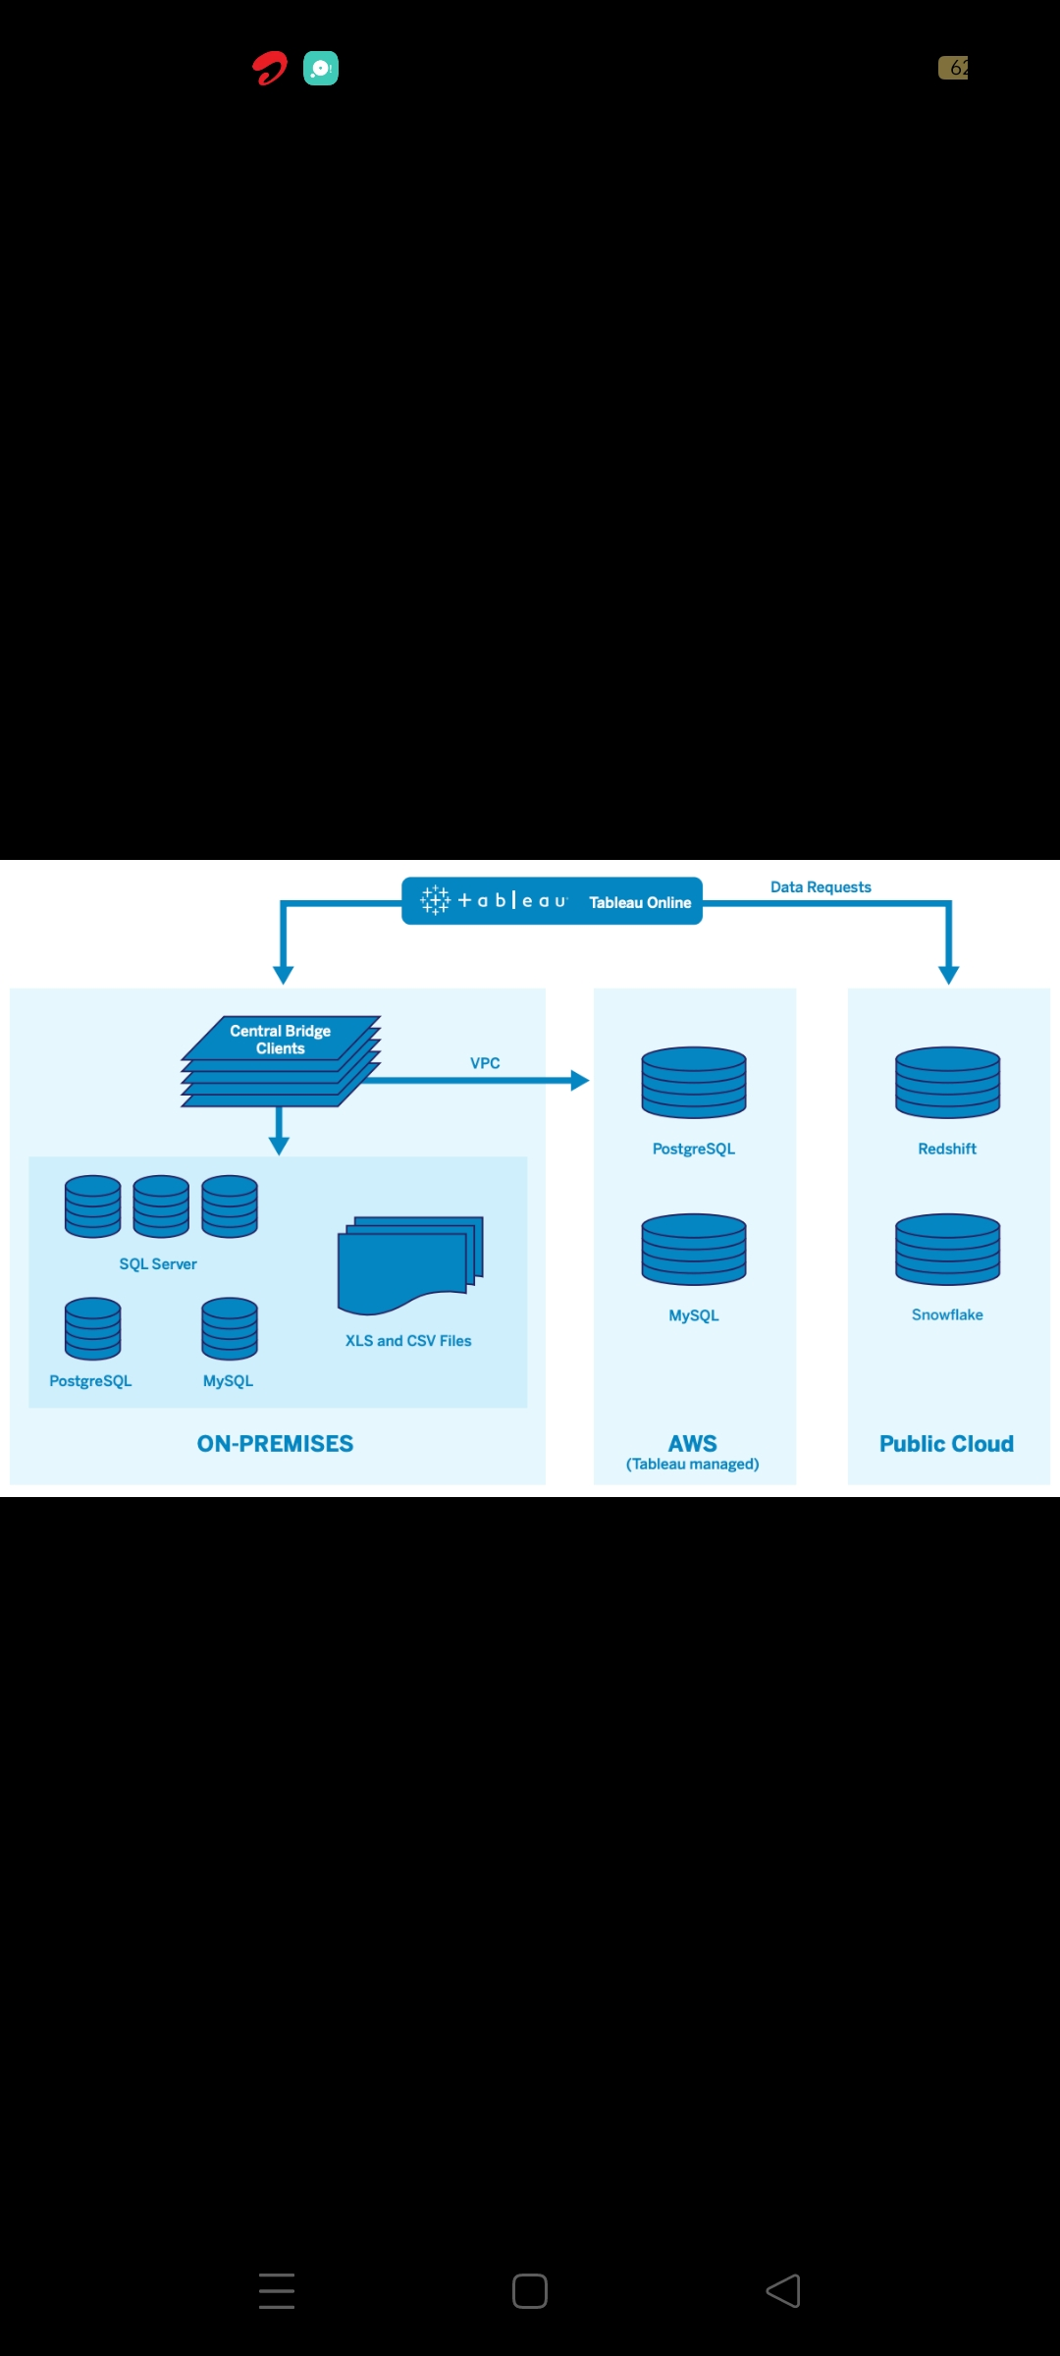
Economic Freedom Dataset
↓
Economic Freedom Analysis System
↓
Charts • Maps • Dashboards • Stories

User Stories
Use the below template to list all the user stories for the product.
User Type | Functional Requirement (Epic) | User Story Number | User Story / Task | Acceptance criteria | Priority | Release
Analyst (User) | Data Collection & Preparation | USN-1 | As a user, I want to collect the Economic Freedom Index 2022 dataset so that I can analyze global economic indicators. | Dataset loads correctly in Tableau | High | Sprint-1
Analyst (User) | Data Cleaning | USN-2 | As a user, I want to clean and preprocess the dataset by handling missing values and formatting fields. | Cleaned data without errors | High | Sprint-1
Analyst (User) | Country-Wise Analysis | USN-3 | As a user, I want to analyze economic freedom scores for all countries using bar charts. | Country-wise charts dispayed | High | Sprint-2
Analyst (User) | Region-Wise Analysis | USN-4 | As a user, I want to calculate average economic freedom scores region-wise for comparison. | Region-wise averages shown | Medium | Sprint-3
Analyst (User) | Map Visualization | USN-5 | As a user, I want to visualize economic freedom scores on a world map for geographical insights. | Map correctly displays scores | High | Sprint-4
Analyst (User) | Dashboard & Story | USN-6 | As a user, I want to combine all visualizations into an interactive Tableau dashboard. I want to create a Tableau story to present insights step-by-step. | Dashboard shows all visuals and Story navigates orrectly. | High | Sprint-4

